**09-11 Numerical Motion Simulations**

**Pizza!**

The vertical motion of human-sized objects on earth’s surface are often well-described by an equation of motion like $m\frac{d^{2}y}{dt^{2}}=m\frac{dv}{dt}=-mg \hat{y}-F_{air} \hat{v}$ assuming upward is +y. For large objects, $F_{air}=\frac{1}{2}C_{D} A ρ v^{2}$, see Open Stax University Physics, sec 6.2 for details. <https://openstax.org/books/university-physics-volume-1/pages/6-4-drag-force-and-terminal-speed>

1. What $C_{D}, ρ, A$ values would be relevant for a pizza that’s dropped from the 13th floor of the really tall dorm on campus (Sheehan?)?
2. What terminal speed will the pizza approach?
3. What mathematical shape will the velocity vs time graph have? Ie, will it be $v\sim t$ or $v\sim t^2$ or $v\sim e^{t}$ or ….? This involves doing an integral, but you don’t have to care about the numerical coefficients.
4. Write a python program that determines the motion of the pizza.
   1. Use a while loop that executes until the pizza reaches the ground.
   2. Your program should use time-steps of no more than $dt<0.1s$ and you could simulate the motion with the simplistic constant-acceleration equations $x_{2}=x_{1}+v_{1}⋅dt+\frac{1}{2}a⋅dt^{2}$ and $v_{2}=v_{1}+a⋅dt$
   3. Your program should create graphs of x vs t, v vs t, and net force vs t. Each graph should display both the simulated (via python) trajectory and the simplistic constant-acceleration equation.
   4. The velocity vs time graph should include an asymptote showing the terminal velocity of a pizza.
5. How do you know your simulation isn’t wrong? Include at least 3 check-your-answer arguments. Possible things to base an argument on are: conservation of energy, limits when air resistance disappears, or maybe pepperoni?

[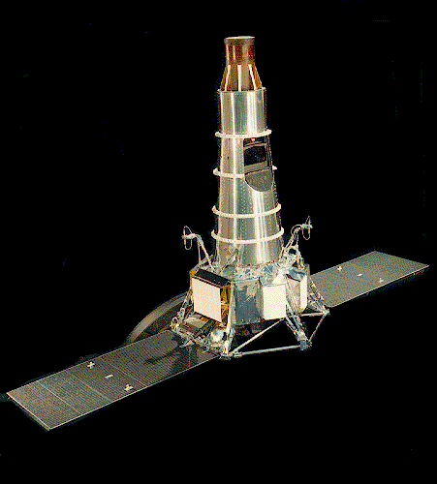](http://nssdc.gsfc.nasa.gov/database/MasterCatalog?sc=1964-041A)**The Ranger 7 Mission**

The first U.S. spacecraft to photograph the Moon close up was the unmanned “Ranger 7” mission, in 1964. The spacecraft contained television cameras that transmitted close-up pictures of the Moon back to Earth as the craft approached the moon. The spacecraft had no way to slow down and eventually made a little crater of its own in the moon. You can see much of the video via this JPL video, <https://www.youtube.com/watch?v=5Z7GGiXRAo0>

To send a spacecraft to the Moon, we put it on top of a large rocket containing lots of rocket fuel and fire the rocket upward. Although the rocket moves quite slowly at first, it rapidly accelerates. As rocket fuel is used up, the corresponding sections of the rocket, called “stages”, fall away. As the mass which needs to be further accelerated decreases, the remaining propellant has an increasingly important effect. By the time the rocket reaches the edge of the earth's atmosphere (about 50 km) the propellant is gone and the rocket coasts to the moon.

The Ranger series of missions is documented on NASA's website, [http://nssdc.gsfc.nasa.gov/](http://nssdc.gsfc.nasa.gov/database/MasterCatalog?sc=1964-041A). Top of Form

Bottom of Form

## Problem

I want you to model the mission from the starting point of about 50 km above the surface of the earth, where the ranger probe has an initial velocity of $V_{0}={10}^{4}\frac{m}{s}$.

Compared to the gravitational force exerted by the earth and the moon, the other planets don't have a big effect on the probe's trajectory. Accordingly, to make the model simple at first, you should ignore the gravitational effects of the other planets. In addition, since the earth takes 365 days to go around the sun, you can assume that from the reference frame of the earth, the moon is basically stationary.

1. Draw a picture and create a force diagram for the Ranger probe as it coasts from the earth to the moon. Write down an F=ma equation that describes the dynamics (relativity is not needed). Determine the necessary masses and distances involved in the problem.
2. What does the net force landscape look like for the duration of the Ranger’s unpowered flight? At what position does the moon’s gravitational pull become larger than the Earth’s? It wouldn’t be wrong to call this place the “point of no return”.
3. What does the potential energy landscape look like for the duration of the Ranger’s unpowered flight? Write down the potential energy function from both masses (Earth and Moon), and show, graphically, the kinetic energy the Ranger must have if it will make it to the moon. Use this to figure out what the minimum engine-off speed is for the ranger at 50km above Earth’s surface.
4. Write a python program that simulates the Ranger’s unpowered motion from earth to the moon.
   1. Use a while loop that stops when either: the ranger gets to the moon’s surface or the ranger falls back to the earth’s surface.
   2. Your program should produce plots of kinetic, potential, and total energy. Adjust dt so that your simulation loses no more than 1% of the system’s energy.
   3. Your program should plot the velocity vs time, position vs time, and velocity vs position of the ranger. Be sure you can explain the shape you see in the v vs x plot (use energy?)
5. If you use an initial speed of 10% more than the minimum speed, how long does it take the Ranger probe to reach the moon? Given this time, is it reasonable to say that the moon and the earth are stationary with respect to each other?
6. Come up with at least 3 checks of your numerical simulation. Ideas:
   1. What were the mission parameters in the 1960’s? Does your simulation match them?
   2. How far does the moon move in the time it takes the ranger to get there? Is a 1-d description reasonable in this case?